I will now be focusing on the edit button: (add this in version3)

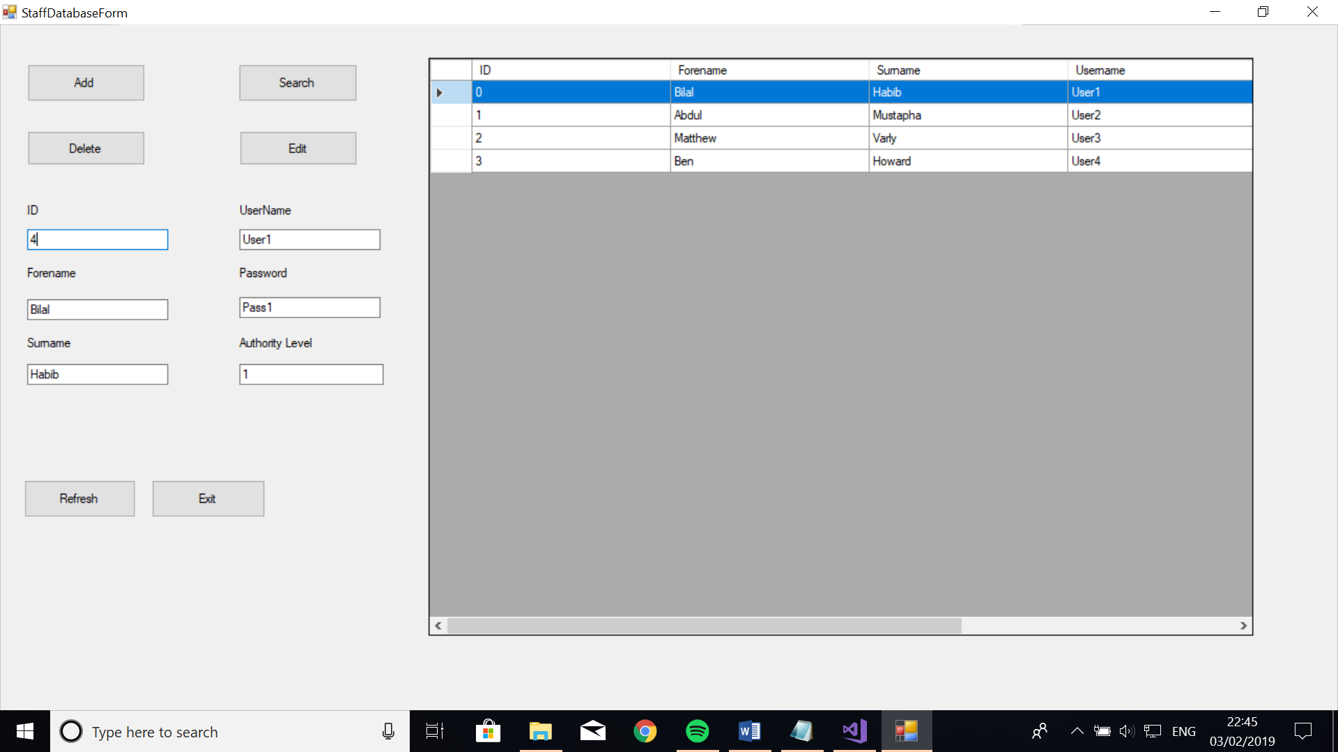

When the user clicks on a record, the details from the record get copied into the textboxes. After that, the user can change whatever needs to be changed in the record and click on the edit button.

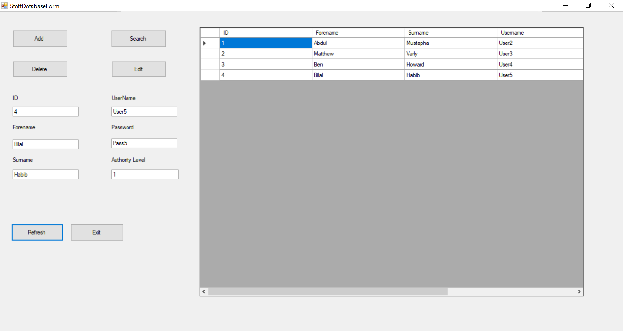

Private Sub cmdEditStaff_Click(sender As Object, e As EventArgs) Handles cmdEditStaff.Click

Delete()

Add()

End Sub

The Edit button Deletes the chosen record and Adds it back into the file with the new details. In this case I changed the ID to 4 and Username to User5. To do this I created two sub procedures for Add and Delete as they have been used more than once in the class and I therefore avoided re-writing the code for the Add and Delete Button.